# Project Design Phase-II Data Flow Diagram & User Stories

|  |  |
| --- | --- |
| Date | 28 June 2025 |
| Team ID | LTVIP2025TMID47877 |
| Project Name | Measuring the Pulse of Prosperity: An Index of Economic Freedom Analysis |
| Maximum Marks | 4 Marks |

Data Flow Diagrams:

A Data Flow Diagram (DFD) is a traditional visual representation of the information flows within a system. A neat and clear DFD can depict the right amount of the system requirement graphically. It shows how data enters and leaves the system, what changes the information, and where data is stored.

DFD Level 0: Overview

* External Entities: Policymaker, Researcher, General User, Administrator
* Processes: Upload Dataset, Analyse Data, Generate Visualizations, Export Reports
* Data Stores: Raw Data, Filtered Results, User Accounts

Example: (Simplified)

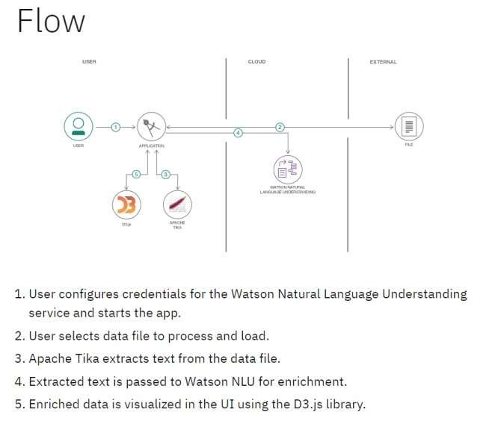

User Stories

Use the below template to list all the user stories for the product.

|  |  |  |  |  |  |  |
| --- | --- | --- | --- | --- | --- | --- |
| User Type | Functional Requireme  nt (Epic) | User  Story  Numbe  r | User Story / Task | Acceptance  criteria | Priority | Release |
| Policymaker | Data  Analysis & Visualizatio n | USN-1 | As a Policymaker, I want to view a world map showing economic freedom scores by country, so that I can quickly identify regions with high or low economic prosperity and potential policy impact areas. | The map correctly displays economic freedom scores, and I can identify regions visually. | High | Sprint-1 |
| Economic Researcher | Data  Analysis & Visualizatio n | USN-2 | As an Economic Researcher, I want to filter economic data by specific years and countries, so that I can conduct in-depth analysis on historical trends and compare performance across different nations. | I can apply filters for years and countries, and the data displayed updates accordingly. | High | Sprint-1 |
| Investor | Data  Analysis & Visualizatio n | USN-3 | As an Investor, I want to see the top 40 and least ranked countries based on their economic index, so that I can identify potential investment opportunities or risks in various markets. | The list of top and least ranked countries is accurate and easily accessible. | High | Sprint-1 |
| User | Data  Ingestion &  Managemen  t | USN-4 | As a User, I want to upload new economic datasets (e.g., CSV, Excel), so that I can incorporate the latest information into the analysis and update the index. | I can successfully upload a dataset, and its data is visible in the system. | Medium | Sprint-2 |
| Economic Researcher | Data  Analysis & Visualizatio n | USN-5 | As an Economic Researcher, I want to view correlations between economic freedom and indicators like unemployment rate and GDP growth, so that I can understand the multifaceted impacts of economic policies. | The system generates a report with selected criteria, and I can download it in my desired format (e.g., PDF). | High | Sprint-2 |
| User | Reporting & Export | USN-6 | As a User, I want to export visualizations (e.g., charts, maps) as image files, so that I can easily include them in presentations or reports. | I can export displayed visualizations as image files (e.g., PNG, JPEG). | Medium | Sprint-1 |
| Administrator | User  Managemen t &  Authorizatio n | USN-7 | As an Administrator, I want to manage user accounts and roles, so that I can access levels to sensitive data and functionalities. | I can add, edit, and remove users, and assign. | High | Sprint-1 |